EXPERIMENT-1
Installation and Configuration of Development Environment
1.Visual Studio Code
Introduction to Visual Studio Code:
Visual Studio Code (VS Code) is a free, lightweight, and powerful source-code editor developed by Microsoft. It supports multiple programming languages and provides tools for coding, debugging, version control, and extensions.
Features of VS Code:
- Free and open-source
- Lightweight and fast
- Supports multiple programming languages
- Built-in terminal
- Git integration
- Intelligent code completion (IntelliSense)
- Debugging support
- Extension marketplace
- Cross-platform support (Windows, Linux, macOS)
Downloading VS Code
Step 1: Visit Official Website
Go to:
Visual Studio Code Official Website
Step 2: Download Installer
- Click Download for Windows
- The installer file (.exe) will start downloading.
Installation Process
Step 1: Run the Installer
Double-click the downloaded file:
VSCodeSetup.exe
Step 2: Accept License Agreement
- Select I accept the agreement
- Click Next
Step 3: Select Installation Location
Default path:
C:\Program Files\Microsoft VS Code
Click Next.
Step 4: Select Additional Tasks
Check:
✔ Create Desktop Icon
✔ Add "Open with Code" action
✔ Add to PATH
✔ Register Code as editor
Click Next.
Step 5: Install
Click Install.
Wait for installation to complete.
Step 6: Launch VS Code
Click Finish.
VS Code opens successfully.
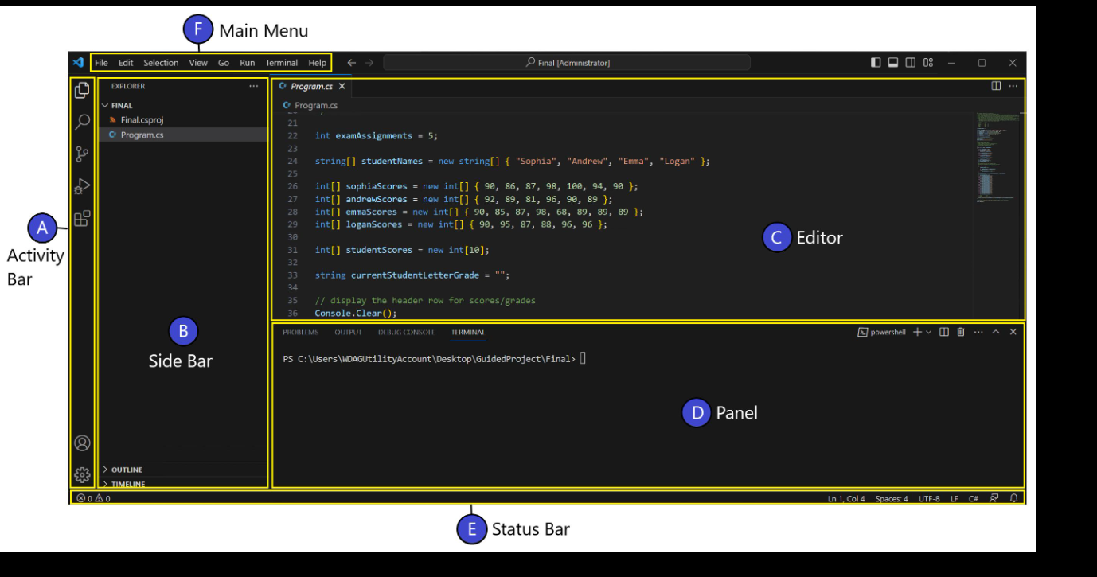
Main Components
1. Activity Bar
Located on the left side.
Contains:
- Explorer
- Search
- Source Control
- Run & Debug
- Extensions
2. Explorer Panel
Displays:
- Files
- Folders
- Project structure
3. Editor Area
Used for writing and editing code.
4. Terminal
Integrated command-line terminal.
Shortcut:
Ctrl + `
5. Status Bar
Located at the bottom.
Shows:
- Language
- Git status
- Errors
- Warnings

Creating a New Project
Step 1
Open VS Code.
Step 2
Click:
File → Open Folder
Step 3
Create a folder:
MyProject
Step 4
Open the folder.
Step 5
Create a new file:
hello.py
or
index.html
Running a Python Program
Create File
print("Hello World")
Open Terminal
Ctrl + `
Run Program
python hello.py
Output
Hello World
Running a Web Project
Create index.html
<!DOCTYPE html>
<html>
<head>
<title>My Website</title>
</head>
<body>
<h1>Hello VS Code</h1>
</body>
</html>
Install Live Server Extension
Right-click:
Open with Live Server
Browser opens automatically.
Advantages of VS Code
- Easy to install and use
- Supports hundreds of programming languages
- Large extension marketplace
- Fast performance
- Built-in debugging tools
- Git and GitHub integration
- AI coding assistant support
- Suitable for beginners and professionals
Applications of VS Code
- Web Development
- Python Programming
- Java Development
- C/C++ Programming
- Data Science
- Machine Learning
- Artificial Intelligence Projects
- Cloud Computing
- Mobile App Development

Result
Visual Studio Code was successfully installed and configured. The development environment is ready for coding, debugging, and software development activities using multiple programming languages and extensions.
2. Python Environment

